# App concept notes:

## Narratives

A user has multiple streaming accounts and wants to watch a specific movie, True Grit starring Jeffrey Bridges. They don’t want to sign into each service, search for the movie, only to discover that it is only available on the 4th service they searched. That’s where our app comes in.

Our app allows users to search multiple streaming services in one location. If the streaming service offers the movie/tv show, our app provides a link to open the movie/TV show in the app streaming it. On first launch the user will be prompted to pick what streaming services they use (or want to see results from), then asked to sign into their accounts (at least Netflix, if it is picked).

## sketches

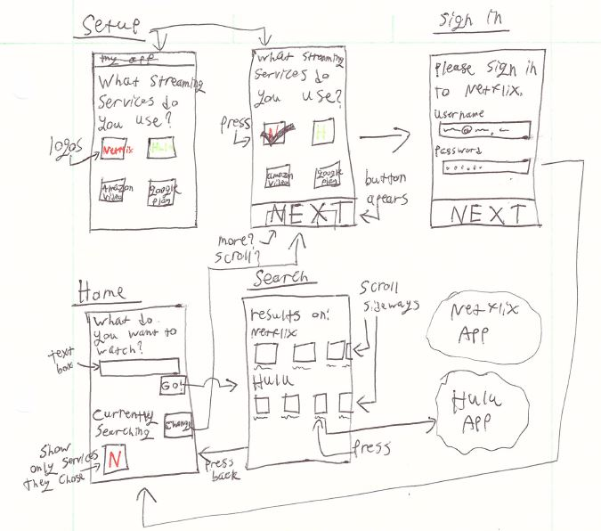

## *categorized* list of use cases

### User use cases

* As a user I want to see if a movie/show is available on Netflix
* As a user I want to see if a movie/show is available on Hulu
* As a user I want to see if a movie/show is available on Amazon Video
* As a user I want to see if a movie/show is available on Google Play (Stretch)
* As a user I want to see how much a movie/show cost to stream (Amazon/Google)
* As a user I want to see suggestions from my streaming services (Stretch)
* As a user I want to be able to open a streaming app from within this one (Stretch)

### Dev use cases

* As a developer I want the app to check an online database (not update a database manually)

## database schema

## screen layouts

### Home

Relative or grid layout

### Login

Linear layout

### Home

Linear or relative layout

### Search

Linear layout

## screen flows

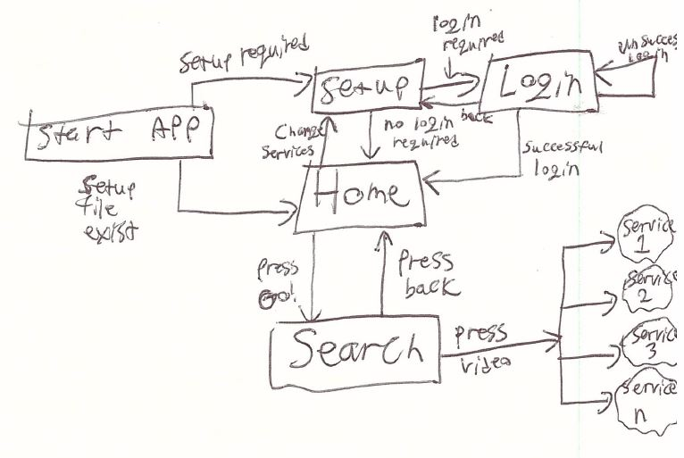

# Object-oriented design of application domain model.

START OF DESIGN  
